Atomically Thin Cesium Lead Bromide Perovskite Quantum Wires with High Luminescence
Hongwen Huang, Mei Liu, Jing Li, Laihao Luo, Jiangtao Zhao, Zhenlin Luo, Xiaoping Wang,* Zhizhen Ye, Haiping He,* and Jie Zeng*

Dr. H. Huang, [†] M. Liu, [†] L. Luo, J. Zhao, Prof. Z. Luo, Prof. X. Wang, Prof. J. Zeng
Hefei National Laboratory for Physical Sciences at the Microscale, Hefei Science Center, National Synchrotron Radiation Laboratory & Synergetic Innovation Center of Quantum Information and Quantum Physics, Department of Chemical Physics
University of Science and Technology of China, Hefei, Anhui 230026, P. R. China

Unlike the widely known zero-/two-dimensional all-inorganic cesium lead halide perovskite (CsPbX3, X = Cl, Br, I) nanocrystals, one-dimensional (1-D) CsPbX3 quantum wires (QWs) with a strong quantum confinement effect are still unexplored. Here, we report a room-temperature colloidal synthesis of few-unit-cell-thick CsPbBr3 QWs with lengths over a hundred nanometers. Owing to the strong quantum confinement effect, the photoluminescent (PL) emission peak of few-unit-cell-thick CsPbBr3 QWs blue-shifted to 430 nm. Notably, the ensemble PL quantum yield (PLQY) of the few-unit-cell-thick CsPbBr3 QWs increased to 21.13% through a simple heat-treatment process. The improvement of PLQY was ascribed to the reduction of the density of surface trap states and defect states induced by heat-treatment process. In addition, the size-dependent bandgap of 1-D CsPbBr3 QWs was presented for the first time. Such few-unit-cell-thick CsPbBr3 QWs with a high PLQY not only represent a promising candidate for optoelectronic devices, but also provide an ideal platform for a myriad of fundamental studies.
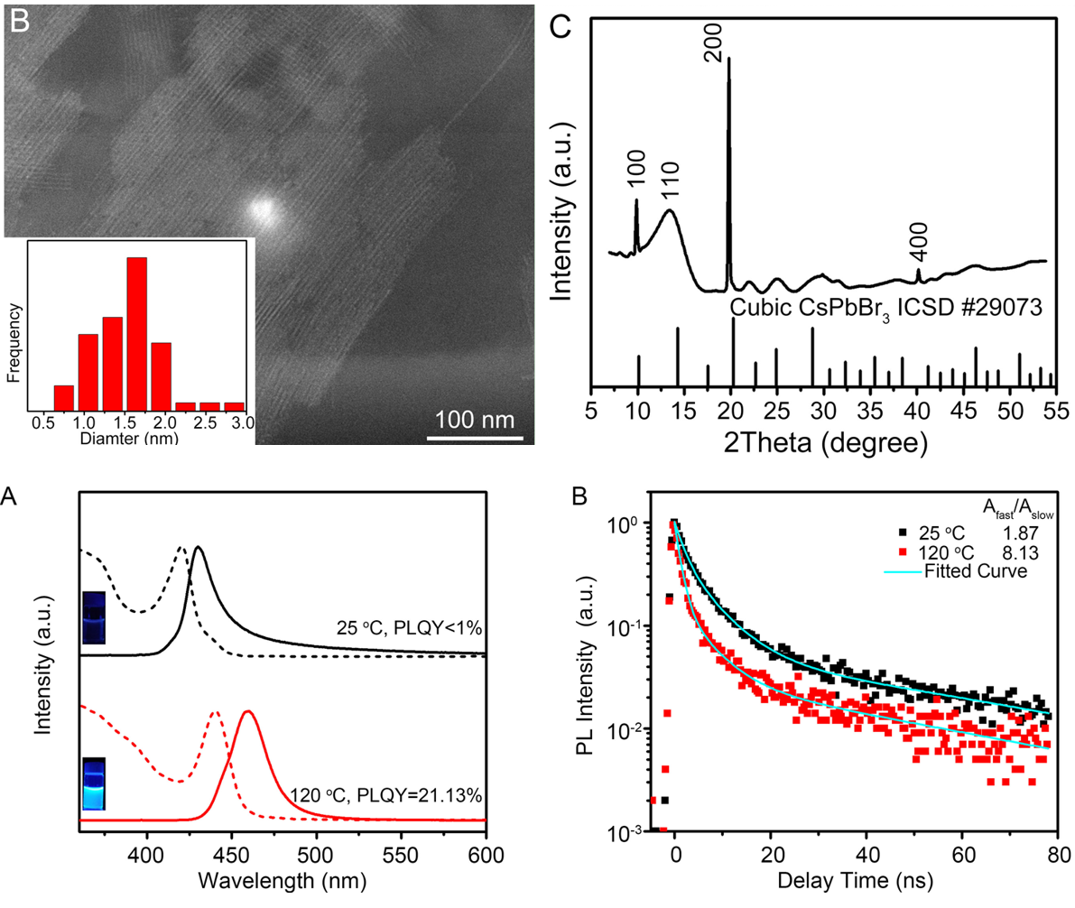
- (a) J. Song, J. Li, X. Li, L. Xu, Y. Dong, H. Zeng, Adv. Mater. 2015, 27, 7162-7167. (b) S. Yakunin, L. Protesescu, F. Krieg, M. I. Bodnarchuk, G. Nedelcu, M. Humer, G. D. Luca, M. Fiebig, W. Heiss, M. V. Kovalenko, Nat. Commun. 2015, 6, 8056. (c) Y. Wang, X. Li, J. Song, L. Xiao, H. Zeng, H. Sun, Adv. Mater. 2015, 27, 7101-7108. (d) Y. Park, S. Guo, N. S. Makarov, V. I. Klimov, ACS Nano 2015, 9, 10386-10393.
- X. Peng, L. Manna, W. Yang, J. Wickham, E. Scher, A. Kadavanich, A. P. Alivisatos, Nature 2000, 404, 59-61.
- (a) L. Protesescu, S. Yakunin, M. I. Bodnarchuk, F. Krieg, R. Caputo, C. H. Hendon, R. X. Yang, A. Walsh, M. V. Kovalenko, Nano Lett. 2015, 15, 3692-3696. (b) Y. Bekenstein, B. A. Koscher, S. W. Eaton, P. Yang, A. P. Alivisatos, J. Am.Chem. Soc. 2015, 137, 16008-16011. (c) Q. A. Akkerman, S. G. Motti, A. R. S. Kandada, E. Mosconi, V. D'Innoscenzo, G. Bertoni, S. Marras, B. A. Kamino, L. Miranda, F. D. Angelis, A. Petrozza, M. Prato, L. Manna, J. Am. Chem. Soc. 2016, 138, 1010-1016. (d) J. Shamsi, Z. Dang, P. Bianchini, C. Canale, F. D. Stasio, R. Brescia, M. Prato, L. Manna, J. Am. Chem. Soc. 2016, 138, 7240-7243. (e) D. Zhang, S. W. Eaton, Y. Yu, L. Dou, P. Yang, J. Am. Chem. Soc. 2015, 137, 9230-9233. (f) D. Zhang, Y. Yang, Y. Bekenstein, Y. Yu, N. A. Gibson, A. B. Wong, S. W. Eaton, N. Kornienko, Q. Kong, M. Lai, A. P. Alivisatos, S. R. Leone, P. Yang, J. Am. Chem. Soc. 2016, 138, 7236-7239.
- (a) A. I. Hochbaum, P. Yang, Chem. Rev. 2010, 110, 527-546. (b) R. Ambigapathy, I. Bar-Joseph, D. Y. Oberli, S. Haacke, M. J. Brasil, F. Reinhardt, E. Kapon, B. Deveaud, A. P. Higginbotham, F. Kuemmeth, T. W. Larsen, M. Fitzpatrick, J. Yao, H. Yan, C. M. Liber, C. M. Marcus, Phys. Rev. Lett. 2014, 112, 216806. (c) T. Schumacher, H. Giessen, M. Lippitz, Nano Lett. 2013, 13, 1706-1710.

姓名：刘美
学号：BA15234048
专业：纳米化学
导师：王晓平
年级：博二

英文投稿,请参考本论文字体及格式。

