Urban Accessibility and Connectivity
Sino-European Joint Call for Proposals

Pre-Proposal: Consortium and General Information
The information in questions 1-4 can also be entered directly into UDiManager. You can complete it in both this form and UDiManager, or only in UDiManager. If you decide to only complete it in UDiManager, please only submit your responses to questions 5-11 as PDF in UDiManager and delete question 1-4 from this document. This application form must be uploaded as one unprotected PDF file (document generated from a word processor file to a PDF, no scanned document).

Please note that when submitting the information of the Chinese applicants, some information must be given both in pinyin and in characters. The information in characters is necessary in order to verify the applicants’ eligibility.
N.B.: Questions and comments in blue may be overwritten or deleted. Please stick to the following formatting requirements: font size: 10 pt, line spacing: 1.15. Both formatting requirements as well as the maximum number of pages (specified in the respective chapters) help the Expert Panel members to read and compare the proposals. Please note that you will be asked by the Call Secretariat to shorten your proposal after submission if the intended page limit is exceeded.

- Project Overview
[General information will also be inserted in the online submission system UDiManager at uefiscdi-direct.ro]
Project Short Title / Acronym:
Project Full Title:
Main Applicant Europe: (Organisation + name of the European main applicant.):
Main Applicant China: (Organisation and name of Chinese main applicant. Please write the Chinese main applicant’s information in both pinyin and characters)
NSFC reference code(申请代码):
Supporting NSFC Grant No.（依托基金）:
Call topics: (tick the relevant call topic(s). You may select both if applicable.)
Topic 1: Sustainable Urban Logistics in the Age of Digitisation
Topic 2: Strengthening Climate-neutral Mobility
Keyword 1:
Keyword 2:
Keyword 3:
Keyword 4:
Keyword 5:
Total Project Costs European side (EUR): |  | Requested funds European side (EUR):
Total project costs Chinese side (RMB): |  | Requested funds Chinese side (RMB):
Total project costs should include any co-funding
Duration of the Project in months (max. 36): |  | Total Effort in Person Months:
Expected start (European side): | [MM.YYYY] | Expected end (European side): | [MM.YYYY]
Expected start (Chinese side) | [MM.YYYY] | Expected end (Chinese side): | [MM.YYYY]

- Abstract
[Information will also be inserted in the online submission system at uefiscdi-direct.ro]
Short presentation of project content and goals (max. 200 words). The abstract should make the project’s goals clear.

- Project Consortium
Please carefully choose the number of partners involved in the pre-proposal in the submission system – UdiManager . Please remember to include the names and organisations of Chinese applicants in both pinyin and characters. Indicate a lead co-applicant if this is required by the eligibility rules of the co-applicants’ national funding agency.
Please note: for the purposes of this table, the project coordinator should be the same as the main applicant on respectively the Chinese and European side.
[Information will be inserted in the online submission system at uefiscdi-direct.ro]
 | Organisation | Type of organisation | Country / Funding agency | Contact Person (first name and family name)
Project Coordinator / Main Applicant Europe
Project Coordinator / Main Applicant China
Project Partner 2
Project Partner 3
Project Partner 4
Project Partner 5

- Financial Information
This section is dedicated to the budget planning for your project. Please carefully check all the information introduced and press the “Save” button after introducing data for each applicant, to make sure your final financial data is correctly displayed. Please note that the financial information for the European side should be entered directly into UDiManager in Euros. For the Chinese side, only the total requested cost needs to be included at this stage, in RMB.
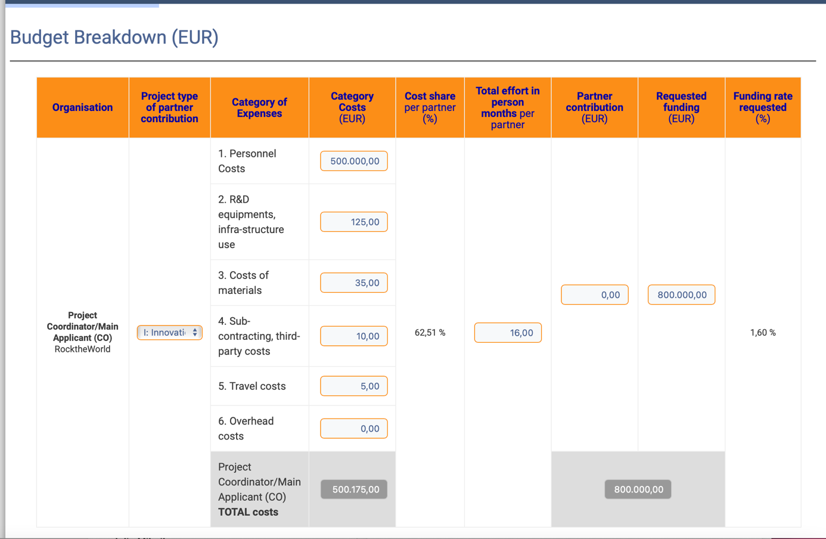

[The responses to questions 5-11must be uploaded as a single PDF to the online submission system at uefiscdi-direct.ro]
This application form must be uploaded as an unprotected PDF file (document generated from a word processor file to a PDF, not a scanned document).
Please stick to the following formatting requirements: font size: 10 pt, line spacing: 1.15. Both formatting requirements as well as the maximum number of pages (specified in the respective chapters) help the Expert Panel members to read and compare the proposals. Please note that you will be asked by the Call Secretariat to shorten your proposal after submission if the intended page limit is exceeded.
- Problem statement, societal impact, project objectives and targets (max. 3 pages)

5.1 Problem statement
5.1.1 Societal problem
What is the societal problem that the project addresses?
5.1.2 Causes
What are the causes of the problem? Which (part of) these cause(s) is related to a lack of knowledge?
5.1.3. Assumptions
Specify at least two assumptions that are made in the formulation of the problem and its causes. Assumptions are often unvoiced or presumed. Making them explicit contributes to a shared image of the problem and its causes.

Intended societal impact
5.2.1 Societal impact
Describe the intended societal impact where the program wants to contribute. Societal impact is defined as cultural, economic, industrial, ecological or social changes that are (partly) the result of research-generated knowledge and skills.
5.2.2 Assumptions
Specify at least two assumptions that are made in the formulation of the societal impact.
5.3 Project objectives and targets
Comprehensibly describe the project’s objectives, and the approaches you intend to use to achieve the defined goals and expected results. Link these to your problem statement and desired societal impact as defined above.
6. Relevance – Contribution of the project to the goals of the call (max. ½ page)
Describe how and to what extent the project addresses the chosen call topic(s). Furthermore, describe how the project contributes to the objectives of the call.
7. Key activities (work programme – max. 1½ pages)
Describe the contents of the envisioned work programme, the results expected within the duration of the project and the main milestones.
8. Data management (max. ½ page)
Provide a brief outline of the data management strategy you plan to implement within your project (see also Annex B of the call text).
9. Added value of Sino-European cooperation (max. ½ page)
Describe the added value of the planned international cooperation, and especially the Sino-European cooperation, with regard to the objectives and targets of your project.
10. Project consortium, trans-disciplinary collaboration, multi-actor involvement, co-creation (max. 2 pages)
10.1 Expertise and complementarity of the consortium
Describe the expertise and experience of the consortium members, how it relates to your proposed research, and how the different areas of expertise and experiences complement each other. Describe how your consortium addresses all scientific, technical and organisational competences required to implement the project, and how the consortium brings together complementary expertise both from within and outside the scientific community.
10.2 Co-creation and co-design with stakeholders
Describe how your project will work in co-creation with stakeholders from outside your consortium. Projects are expected to be cross-sectoral and will be required to clearly engage relevant stakeholders, including the public sector, private sector, civil society and academia, throughout the duration of projects. Projects must also have an interdisciplinary approach, including relevant disciplines, such as natural sciences, social sciences, technical sciences, as well as from applied fields, as well as a transdisciplinary approach that includes knowledge from outside academia, to support and implement integrative approaches and strategies to enhance urban accessibility and connectivity.
11. References (max. 1 page)
Add relevant references.

Detailed financial information on the European side must be given in the Financial Information section on uefiscdi-direct.ro
Type of organisations: University or Other Educational Institution; Public or Private Research Organisation, Business – SME; Business – Large Enterprise; Urban public authority; Other Public / Governmental Institution*; Special Interest Group**; Other Non-Profit Organisation * Other Public/Governmental Institution: e.g., hospital, other public utility, public infrastructure company; ** Special Interest Group: e.g., union, chamber. Note: With regard to the size of companies, for all EU member states the current definitions of SMEs given in the EU competition law are applied (definition of small and medium-sized enterprises and of independent businesses in accordance with recommendation 2003/361/EC of the Commission dated 6 May 2003, [ABl. L 124 of 20.5.2003, pp. 36-41]; cf. https://ec.europa.eu/growth/smes/sme-definition_en).
For the purposes of this table, the project coordinator must be the same as the main applicant on respectively the Chinese and European side.
“Project Partner” in this table means a Co-Applicant or a Cooperation Partner (see chapter 3 of the call text).

